**MIDDLETON CHENEY FOOTBALL CLUB**

**ANNUAL GENERAL MEETING**

**1988**

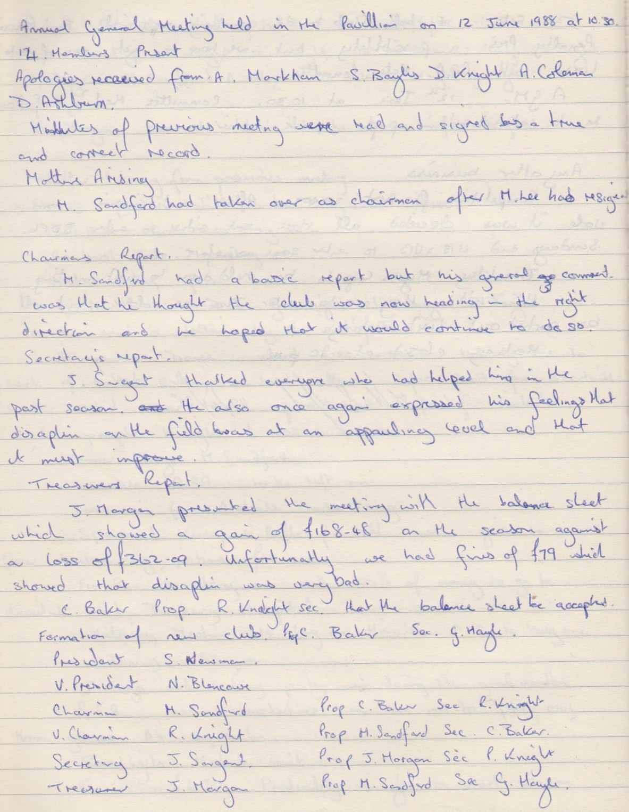

**Continued**

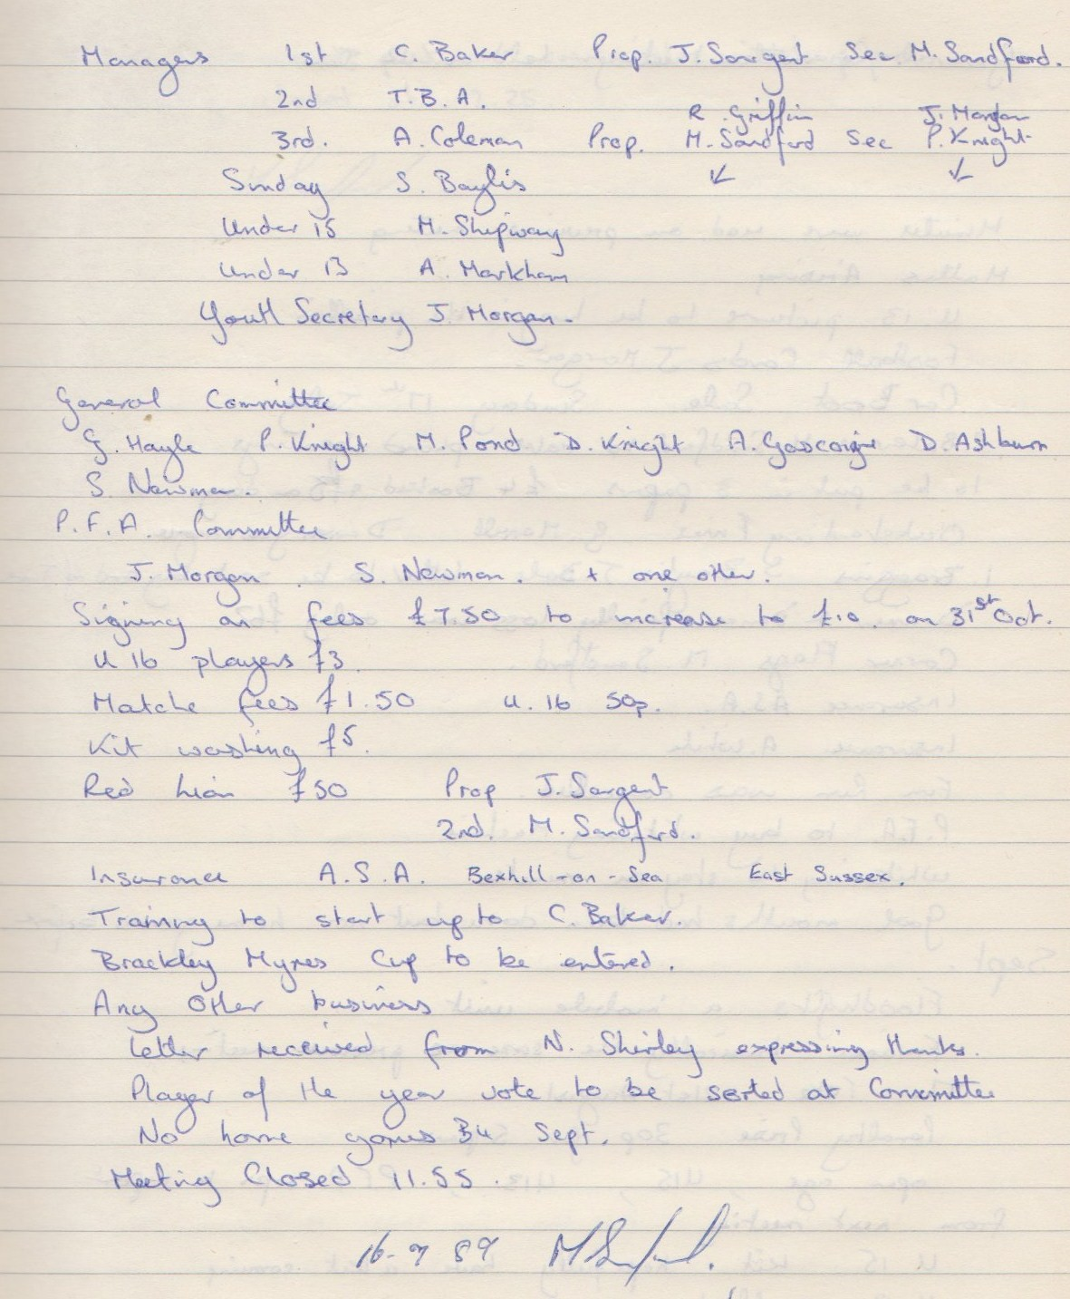

**General Committee Meeting**

**June 12th 1988**

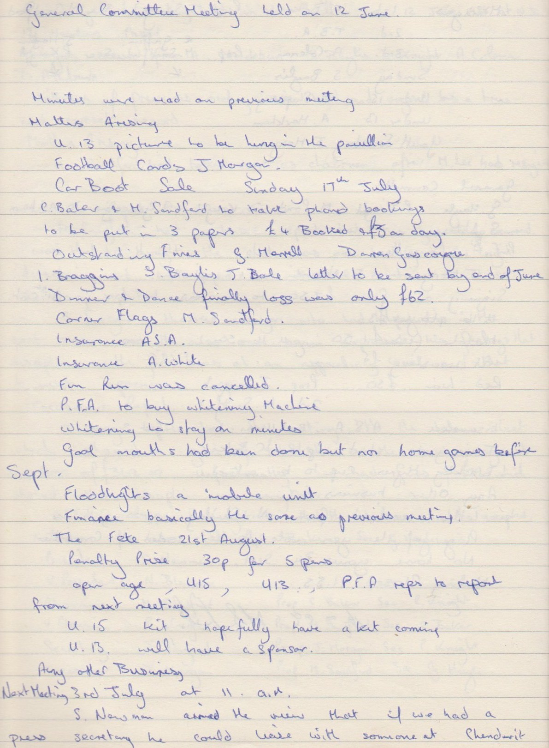

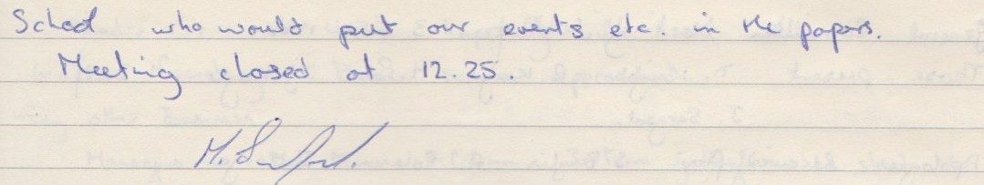

**General Committee Meeting**

**July 3rd 1988**

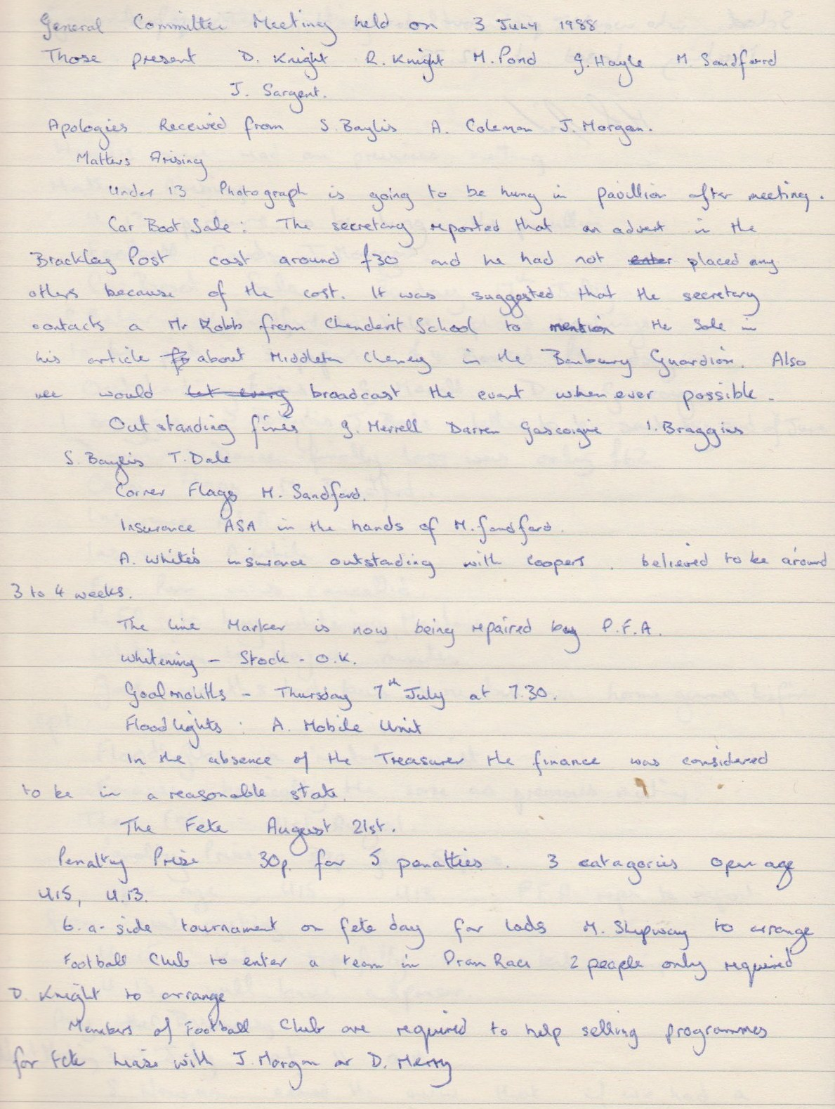

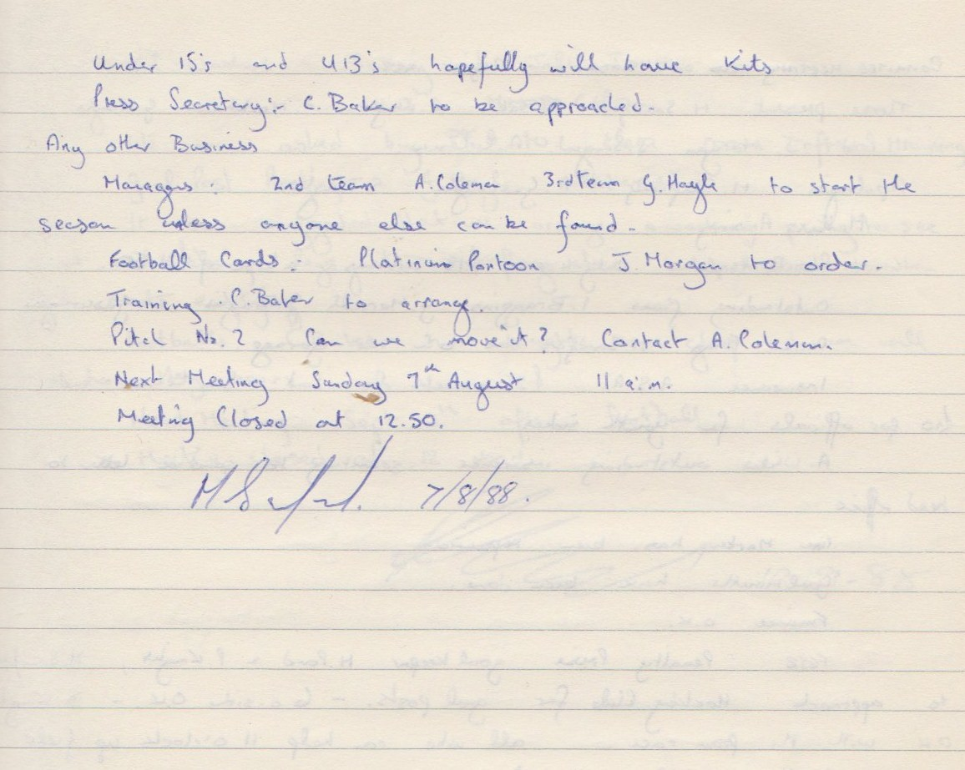

**General Committee Meeting**

**August 7th 1988**

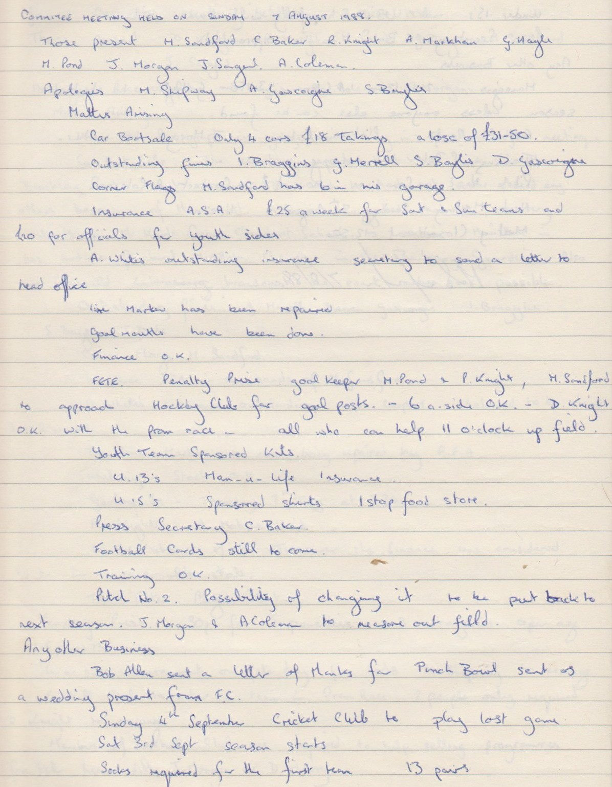

**Continued**

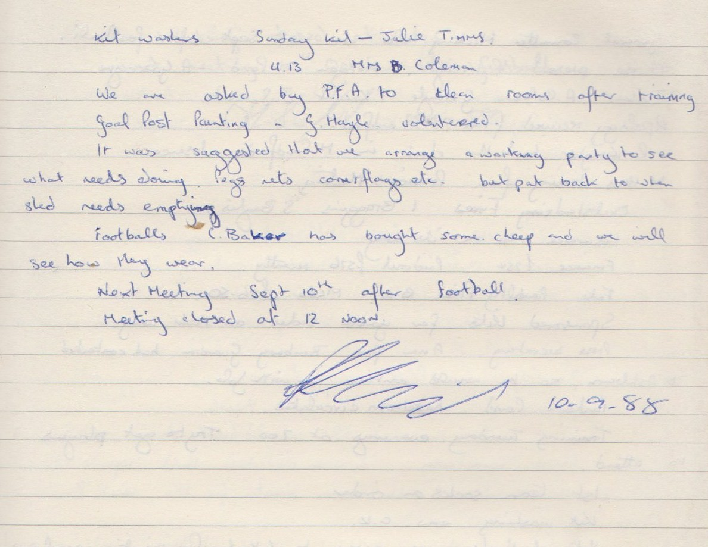

**General Committee Meeting**

**September 10th 1988**

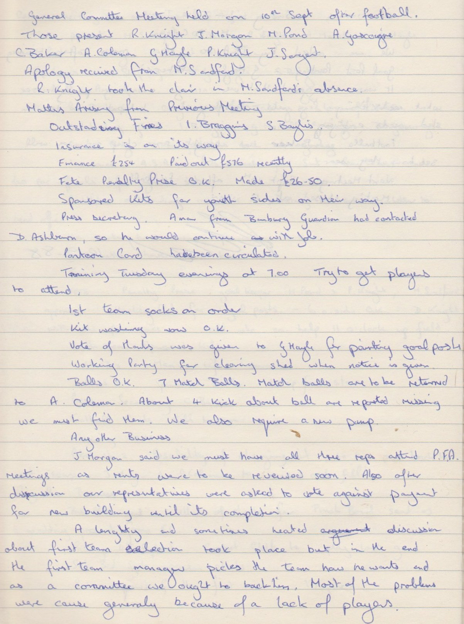

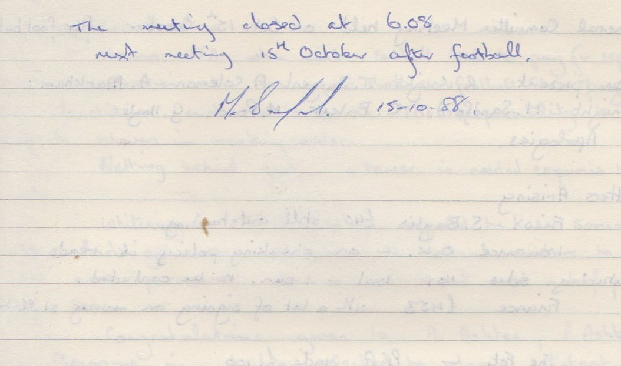

**General Committee Meeting**

**October 15th 1988**

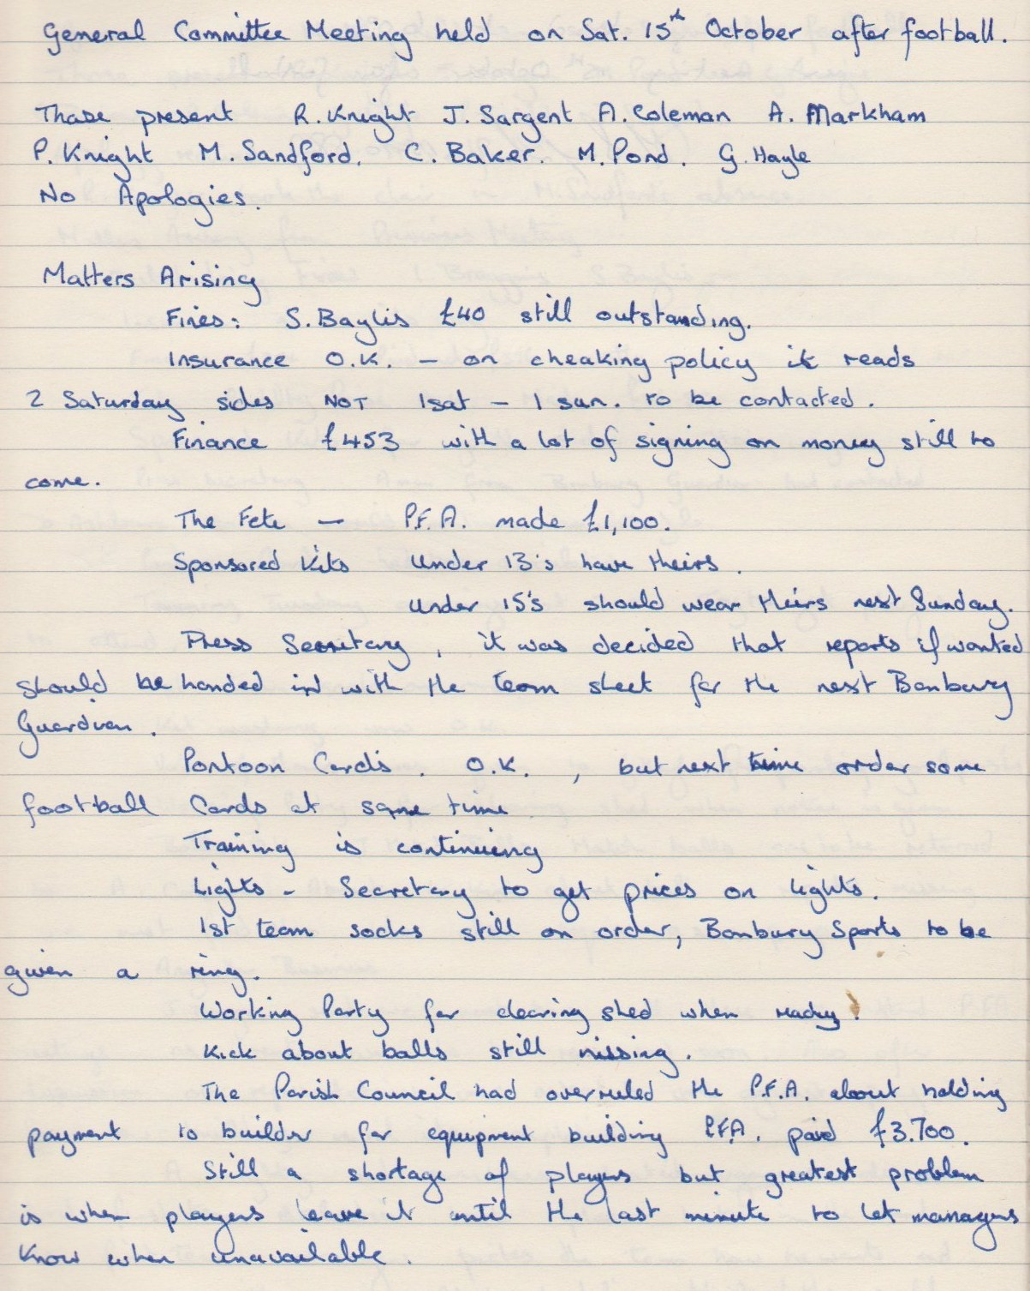

**Continued**

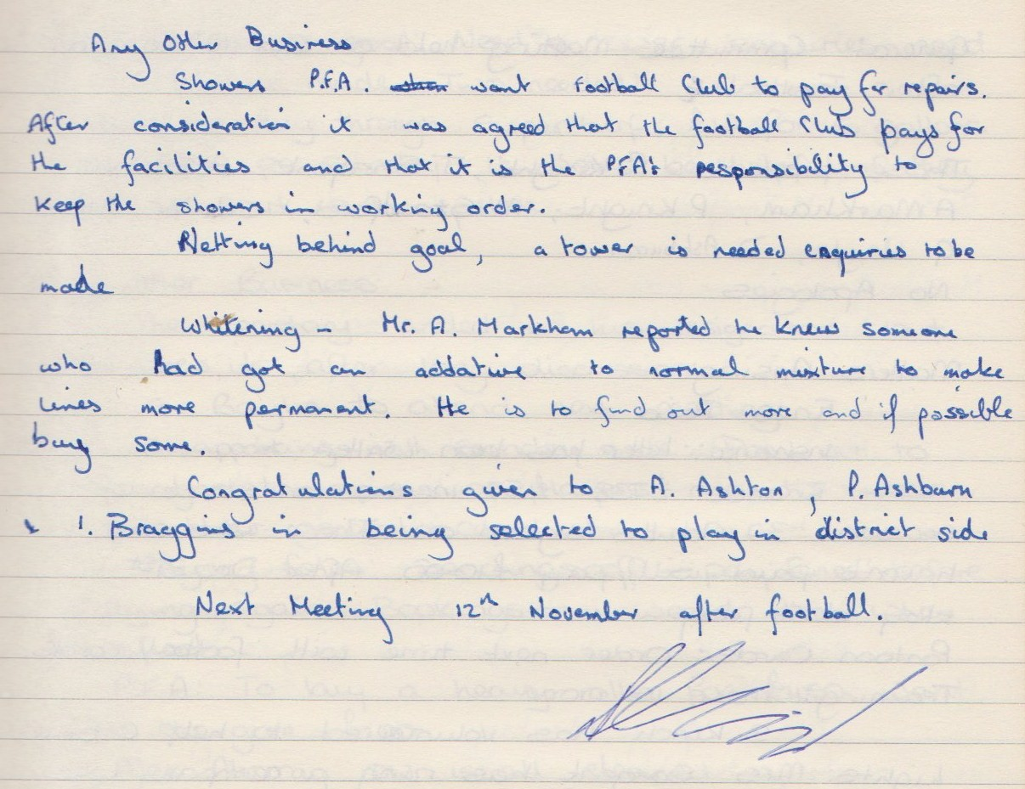

**General Committee Meeting**

**November 12th 1988**

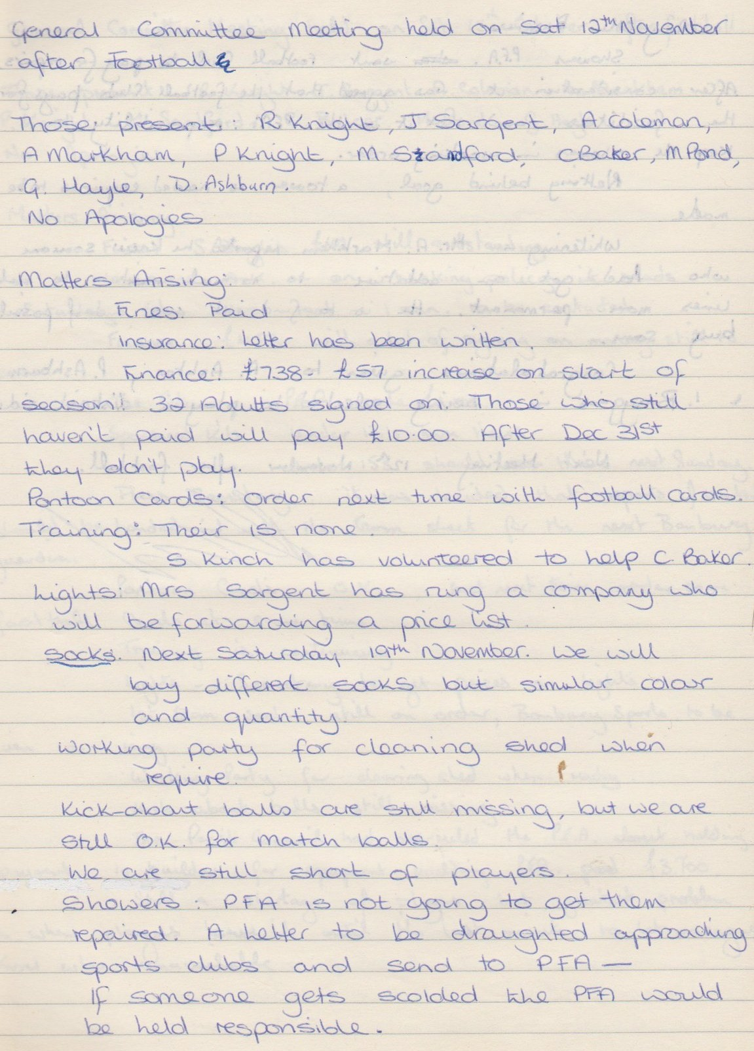

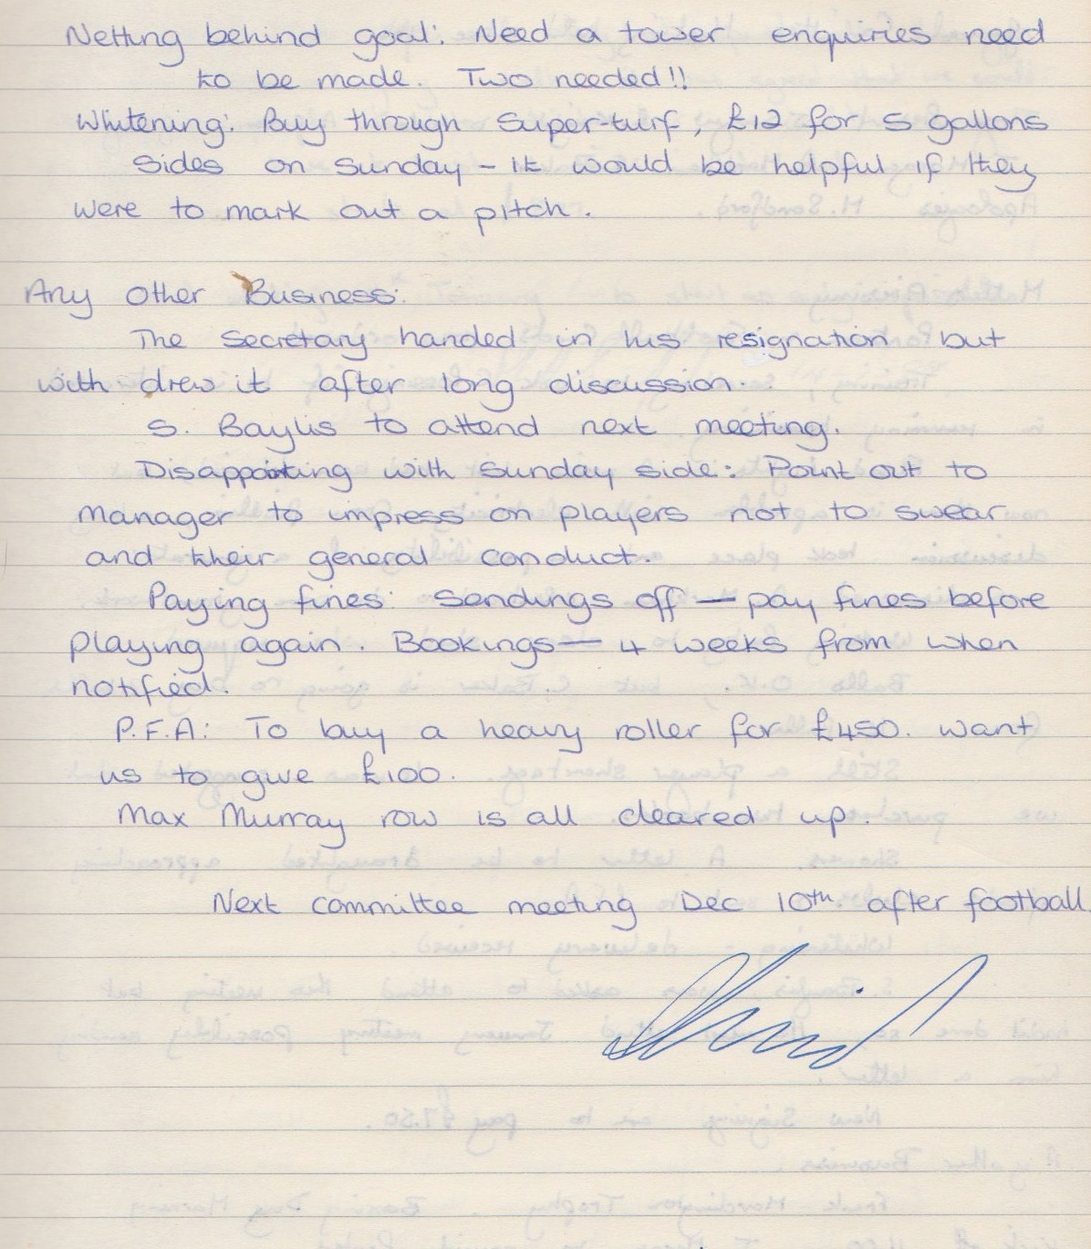

**General Committee Meeting**

**December 10th 1988**

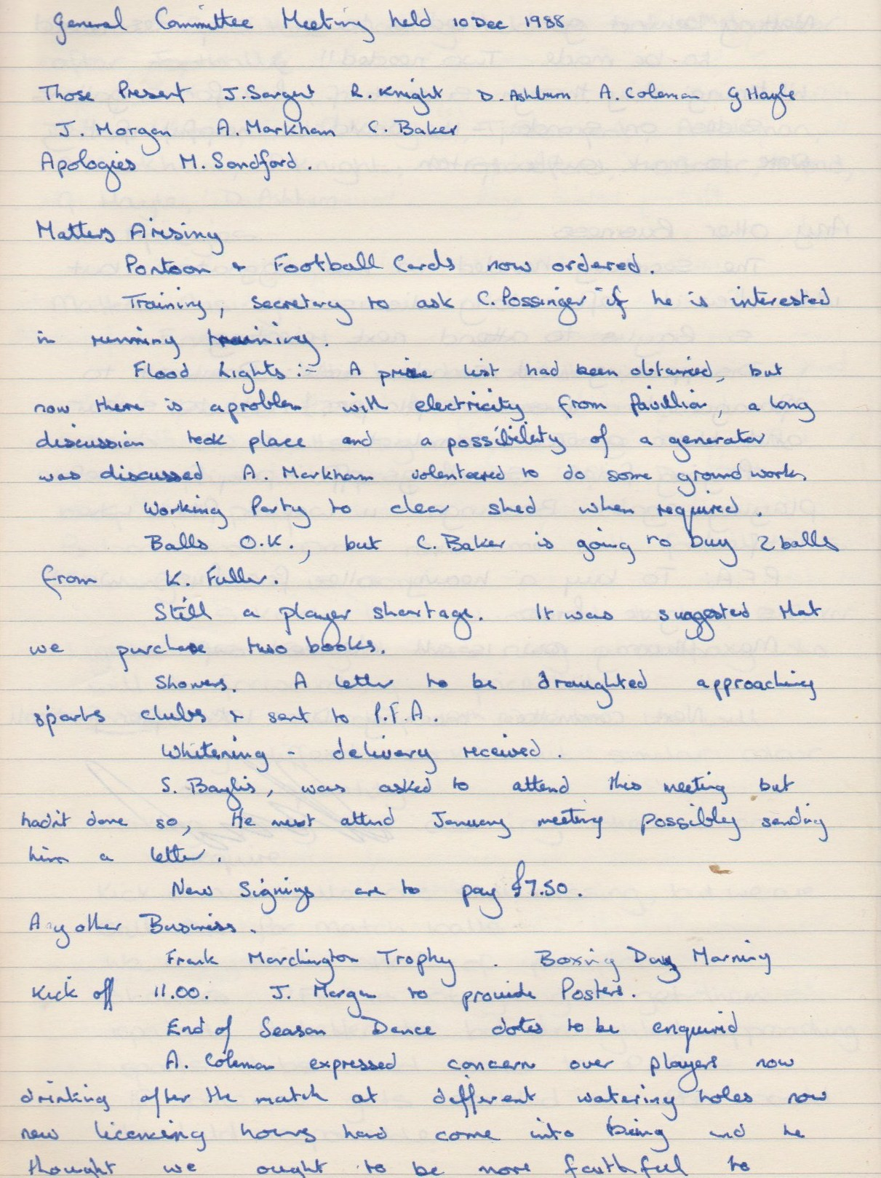

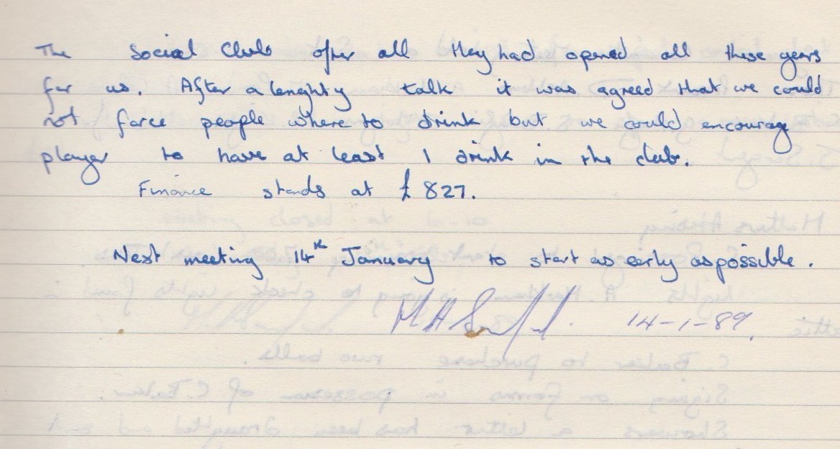

**General Committee Meeting**

**January 8th 1989**

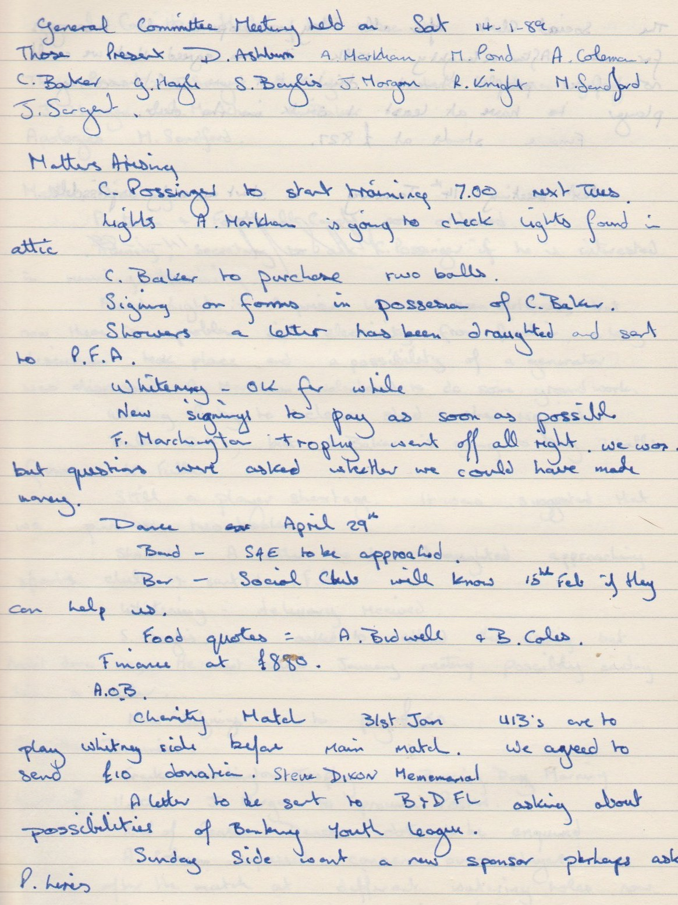

**Continued**

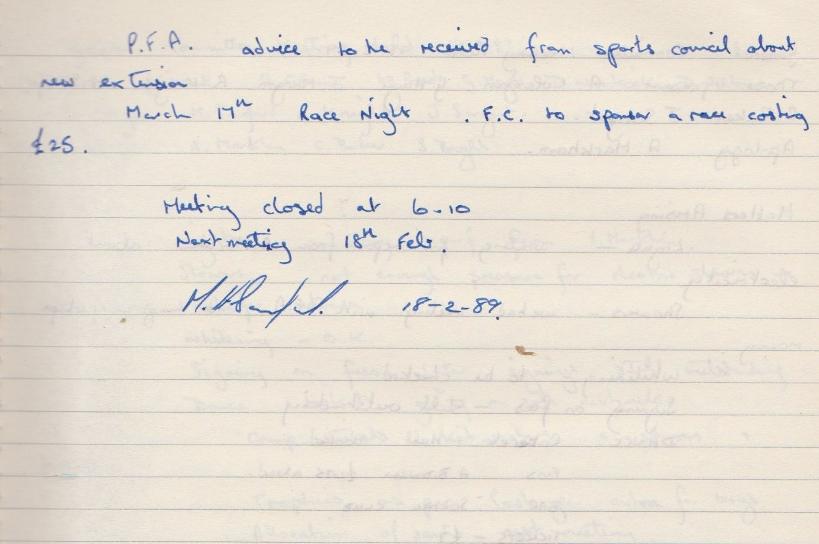

**General Committee Meeting**

**February 18th 1989**

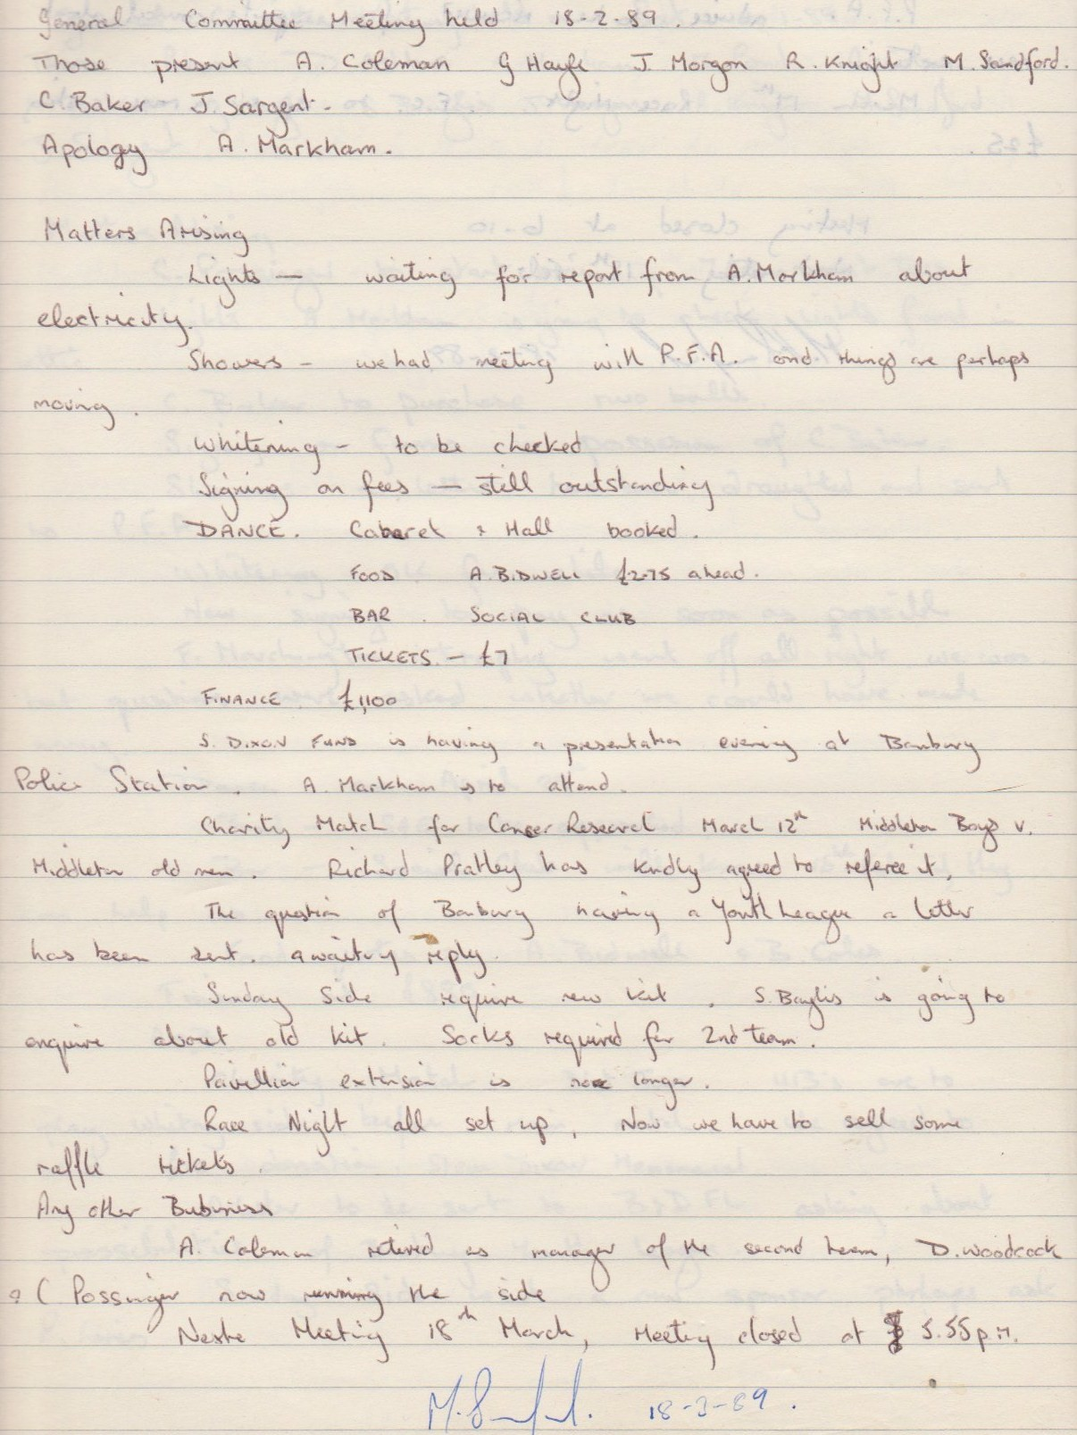

**General Committee Meeting**

**March 18th 1989**

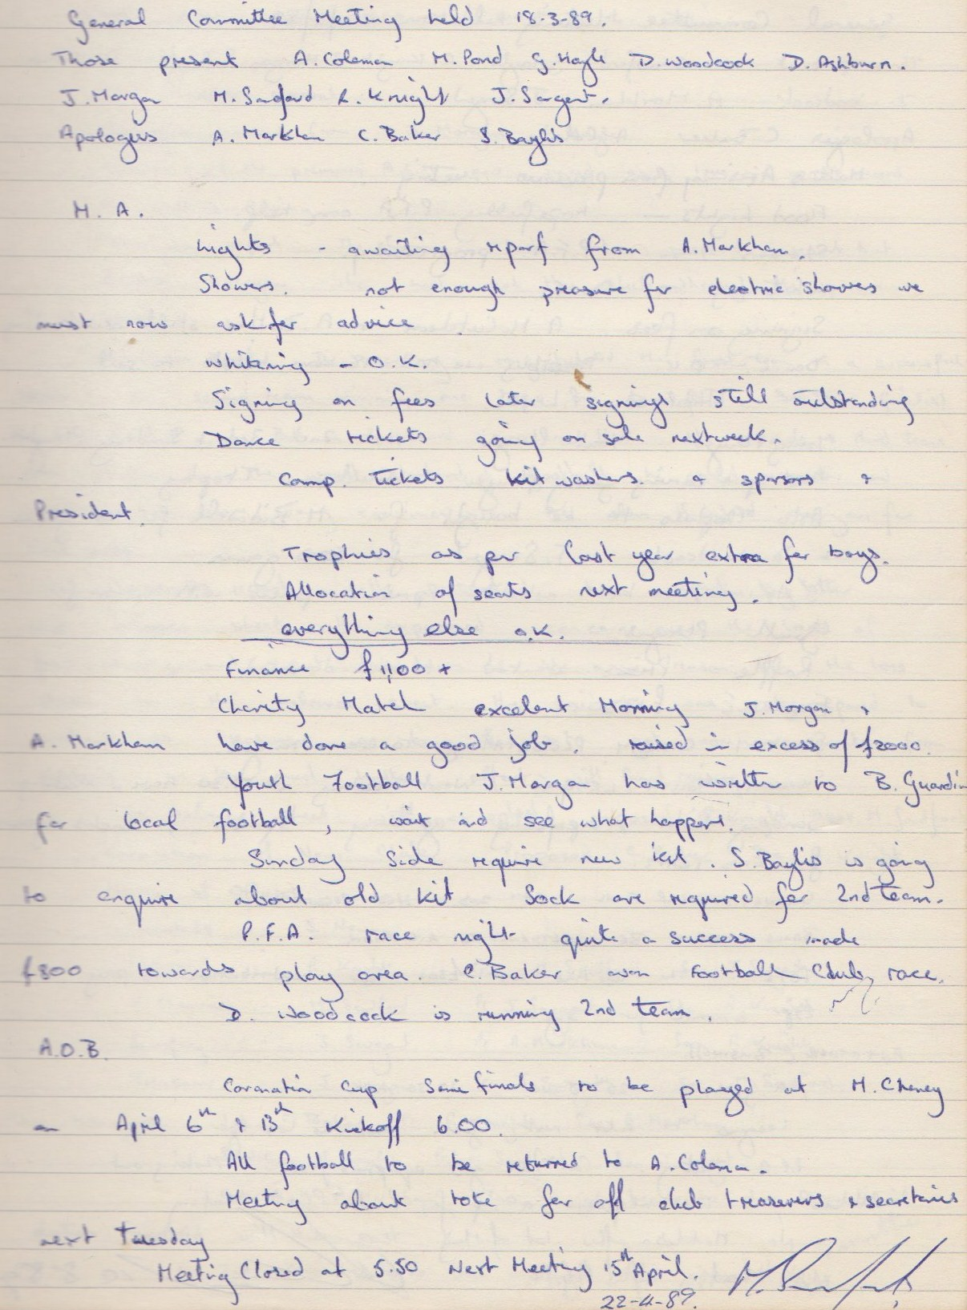

**General Committee Meeting**

**April 22nd 1989**

